The Quilts of Tears Display Rack Diagram
Attention: Schedule 40 PVC Pipe is used
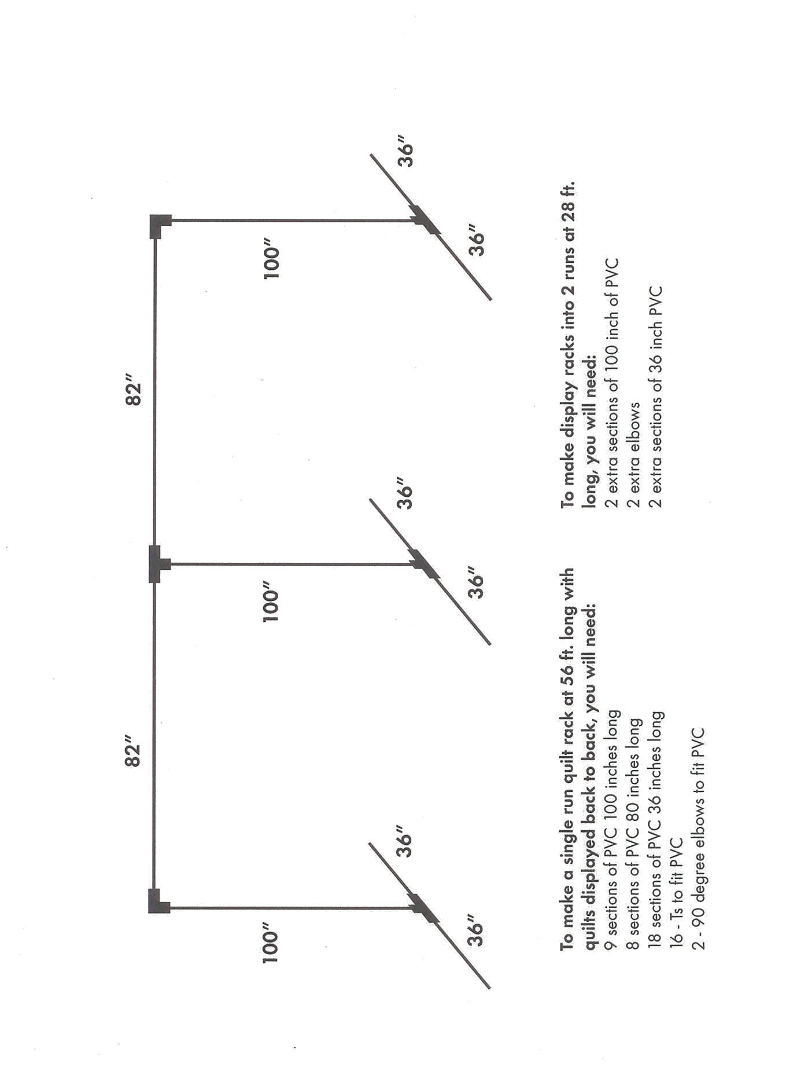
This is just an example the amounts of PVC pipe change from time to time as we add quilts at this time we have 25 quilts so build accordingly

